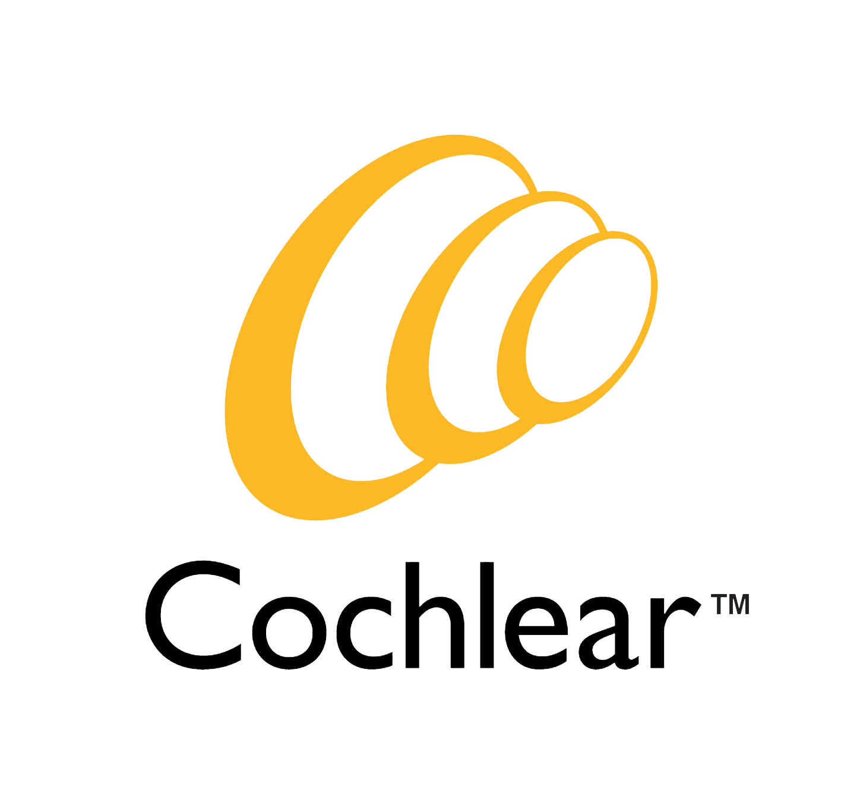 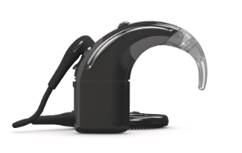N8/CP1100 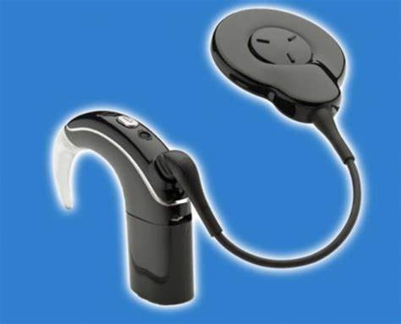 N7/CP1000
………………………………………………………………………………………….

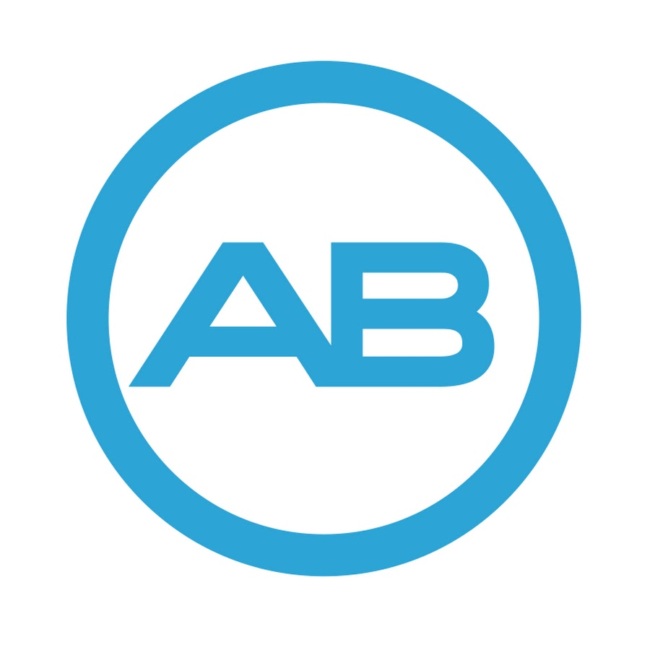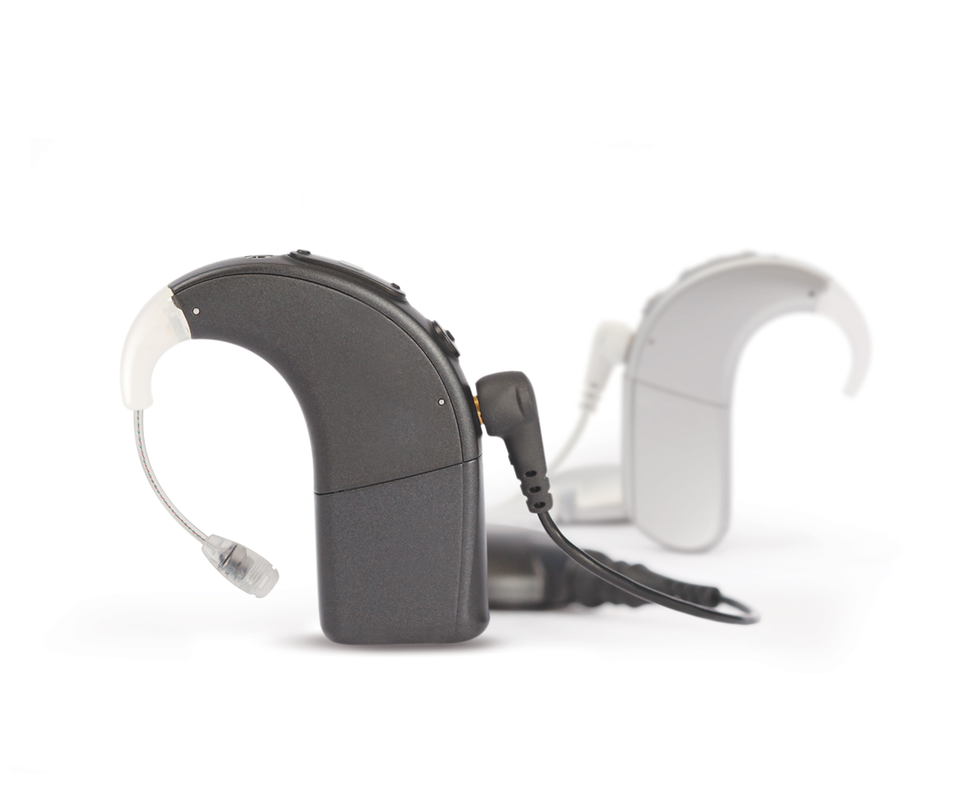AB Naida Q90 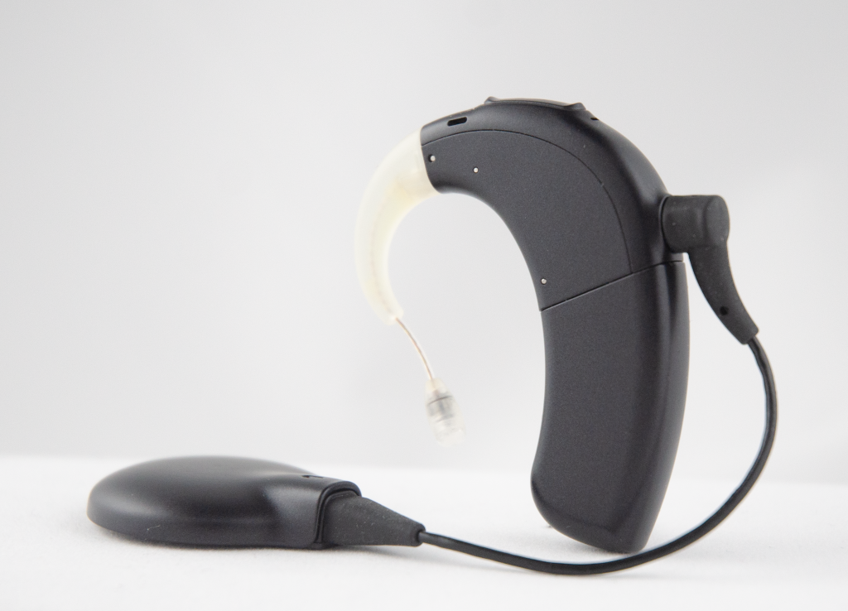 AB Marvel
…………………………………………………………………………………………………………………..
 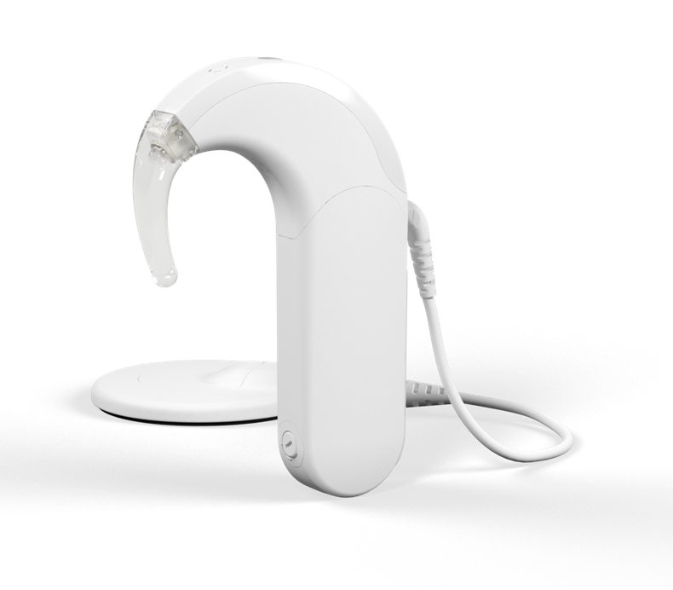Sonnet 2

FREE* COURSE - Device Troubleshooting Workshops

*Free to those supporting USAIS patients (those who do not will be charged £25)

Date: Monday 3 February 2025
Time: 9:30 am – 12:30 pm
Venue: University of Southampton, Avenue Campus

This half day course is run for anyone working with a cochlear implant user who would like to feel more confident handling speech processors.

You will have time working in small groups handling the processors and accessories, including trouble shooting. Delegates will be asked to choose 1 or 2 out of the 3 cochlear implant companies that they would like to spend time learning about (MED-EL, Advanced Bionics and Cochlear). If you only work with one manufacturer, the session will be shorter for you.

Booking Information
To book online Southampton University Online Store. If you have any questions, please contact Anna Read on 023 8059 3522 or email AIS.Training@soton.ac.uk

