Participant Information Sheet

Tinnitus experience in D/deaf and severe to profound hard of hearing adults.

We invite you to take part in a research study
- Before you decide whether to take part, it is important for you to understand why the research is being done and what it will involve.
- Please take time to read the following information carefully. Discuss it with friends and relatives if you wish.
- You are free to decide whether to take part in this study. If you choose not to take part, this will not affect the standard of care you receive.
- Ask us if there is anything that is not clear or if you would like more information.
Important things that you need to know
- Tinnitus is the name for hearing or feeling noises that are not caused by an outside source.
- People with hearing loss often have tinnitus.
- This study is seeking to learn more about people’s experiences of deafness and tinnitus.
- This is so we can address how to better treat tinnitus in people who are D/deaf or have severe to profound hearing loss.
- Taking part in this study will involve being interviewed for about an hour and completing health questionnaires.
- You can choose to be interviewed face-to-face or online. You can bring a family member if you want, and we can provide support such as BSL interpreter. Please ask.
Contents
- Why are we doing this study?
- Why am I being asked to take part?
- What will I need to do if I take part?
- Will my results be kept confidential?
- What will happen to the results?
- Who is organising and funding the study?
- Who has reviewed the study?
- Who do I speak to if problems arise?
- How to contact us
- Where to find us
- Additional information

How to contact us
To find out more or register your interest, please email:
lama.alzahrani@nottingham.ac.uk or tel/text: 07495339862 (Relay UK app connected)

1 Why are we doing this study?

This study will explore the experience of tinnitus in adults who are D/deaf or have a severe or profound hearing loss.

We want to understand how tinnitus affects the everyday lives of people who have little hearing, how they cope with it, what healthcare they access, and what other support they have or need.

The purpose of collecting this information is to determine what healthcare services can and should provide. Also, to prioritise research activities that address questions that are important to adults who are D/deaf or have a severe or profound hearing loss and have tinnitus.
- This study might not directly benefit you, but the information you provide will contribute to an in-depth insight into how people with little hearing perceive tinnitus and the problems they face.
2 Why am I being asked to take part?
You are eligible to participate if you:
- Are 18 years of age or over.
- Are Deaf, deaf or have a severe or profound hearing loss.
- Have tinnitus.
- What will I need to do if I take part?
- You will be asked to complete some questionnaires and then you will be interviewed.
- Interview can be face-to-face at Ropewalk house or held remotely and Interview usually lasts an hour.
- BSL Interpreter can be provided.
- If meeting online, please let us know which you prefer (Zoom, Facetime, MS Teams, for example)
- We offer complementary Amazon vouchers for your time.
- Will my results be kept confidential?
- If you join the study, we will use information collected from you during the course of the research. And your information will be kept strictly confidential, stored in a secure and locked office, and on a password protected database at the University of Nottingham.
- Under UK Data Protection laws the University is the Data Controller (legally responsible for the data security), and the Chief Investigator of this study (named above) is the Data Custodian (manages access to the data) which means we are responsible for looking after your information and using it properly.
- Your rights to access, change or move your information are limited as we need to manage your information in specific ways to comply with certain laws and for the research to be reliable and accurate. To safeguard your rights, we will use the minimum personally – identifiable information possible.
- You can find out more about how we use your information and to read our privacy notice at:

- https://www.nottingham.ac.uk/utilities/privacy.aspx.
- Your participation is voluntary, and you are free to withdraw at any time, without giving any reason, and without your legal rights being affected.
- To safeguard your rights, we will use the minimum personally identifiable information possible.
- What will happen to the results?
- Results will be written for academic publication and presented at research conferences.
- All study data will be anonymised, and you will not be identified in any arising report or publication.
- Organising and funding the study?
This research is being organised by the University of Nottingham and funded by King Abdul-Aziz University, a public university in Jeddah, Saudi Arabia.
- Who has reviewed the study?
This study has been reviewed and given favourable opinion by:
- Faculty of Medicine & Health Sciences, Research Ethics Committee (FMHS 254-0521)
- University of Nottingham
- Who do I speak to if problems arise?
- Our staff always tries to conduct the research in a way that is caring and respectful.
- If you do have any complaint about the way, you have been dealt with during the study or any possible harm you might experience, we would be happy to address it with you directly: Chief investigator: Derek Hoare
NIHR Nottingham Biomedical Research Centre, Ropewalk House, 113 The Ropewalk, Nottingham, NG1 5DU
- If you remain unhappy and wish to complain formally, you should then contact the FMHS Research Ethics Committee Administrator, c/o The University of Nottingham, Faculty PVC Office, E41, Medical School, Queen’s Medical Centre Campus, Nottingham University Hospitals, Nottingham, NG7 2UH. E-mail: FMHS-ResearchEthics@nottingham.ac.uk
- How to contact us
If you have questions and would like to discuss the research further, please contact/ text:
Lama Alzahrani
Text/Tel: 07495339862 Relay UK app connected
Email: lama.alzahrani@nottingham.ac.uk

- Where to find us

We are located within Ropewalk House in the ‘Castle Zone’ of Nottingham City Centre, just off Derby Road and Maid Marian Way. We are close to public transport routes and car parks.
By SatNav or GPS
Post code NG1 5DU
Street name The Ropewalk
Co-ordinates:
Longitude: -1.1599686145782
Latitude: 52.95479219521181
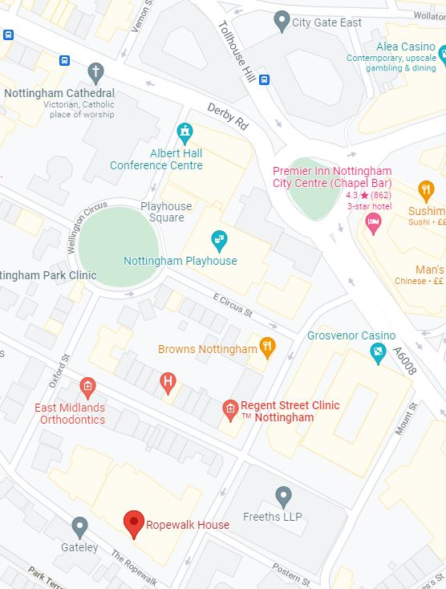

Parking
Follow signs for the city centre and the ‘Castle Zone’. Nearest car parks are Mount Street and St James’s Street. Metered car parking on The Ropewalk is available (£2.40/hr), including spaces for blue badge holders

no charge).

By bus
For bus times call Nottingham City Transport on 0115 950 6070, Traveline on 0871 200 2233, www.travelineeastmidlands.co.uk.

By tram
‘Market Square’ and ‘Royal Centre’ are the two closest tram stops to our unit. Park and ride sites are available. See: www.thetram.net.

By train
Nottingham train station is close by. See: www.nationalrail.co.uk/stations_destinations/not.aspx

On arrival
Upon arrival to Ropewalk, you can approach reception desk.

- Additional information
Privacy information for Research Participants
For information about the University’s obligations with respect to your data, who you can get in touch with and your rights as a data subject, please visit: https://www.nottingham.ac.uk/utilities/privacy.aspx.
Why we collect your personal data
We collect personal data under the terms of the University’s Royal Charter in our capacity as a teaching and research body to advance education and learning. Specific purposes for data collection on this occasion are to understand tinnitus experience in Deaf/deaf and severe-profound hearing-impaired adults so we will only need age, ethnicity, onset of hearing loss.
Legal basis for processing your personal data under GDPR
The legal basis for processing your personal data on this occasion is Article 6(1a) consent of the data subject.
How long we keep your data
The University may store your data for up to 25 years and for a period of no less than 7 years after the research project finishes. The researchers who gathered or processed the data may also store the data indefinitely and reuse it in future research. Measures to safeguard your stored data include anonymization of the data, which will be stored on password protected systems.
What will happen if I don’t want to carry on with the study?

Your participation is voluntary, and you are free to withdraw at any time, without giving any reason, and without your legal rights being affected. If you withdraw, we will no longer collect any information about you or from you, but we will keep the information about you that we have already obtained as we are not allowed to tamper with study records and this information may have already been used in some analyses and may still be used in the final study analyses. To safeguard your rights, we will use the minimum personally identifiable information possible.

